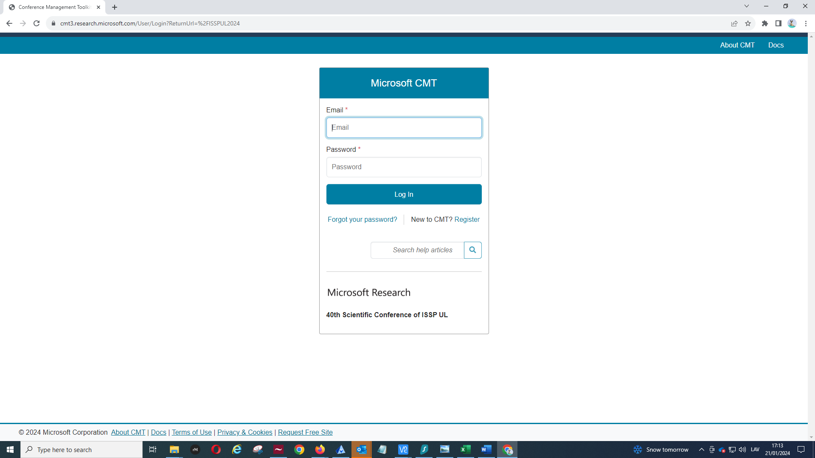

Observe: Microsoft Research 40th Scientific Conference of ISSP UL
For registered users: enter email address and password.
If unregistered: press register

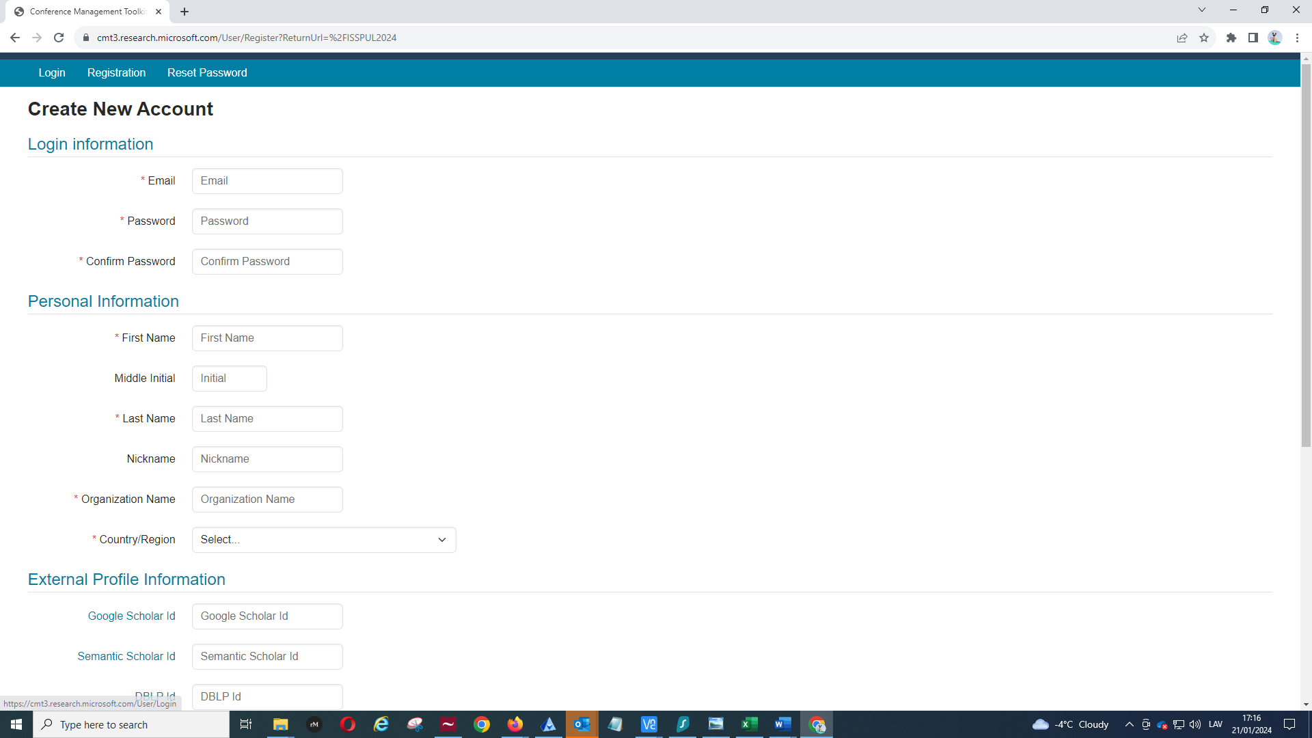

Enter the required information and press Register. After the registration, the system will send you the verification email to check your email.
When fully registered, use the initial link (https://cmt3.research.microsoft.com/ISSPUL2024) to access the platform.
If you try to access the platform not using the conference link, you may not be able to submit your abstract, so please, use the link of the conference: https://cmt3.research.microsoft.com/ISSPUL2024
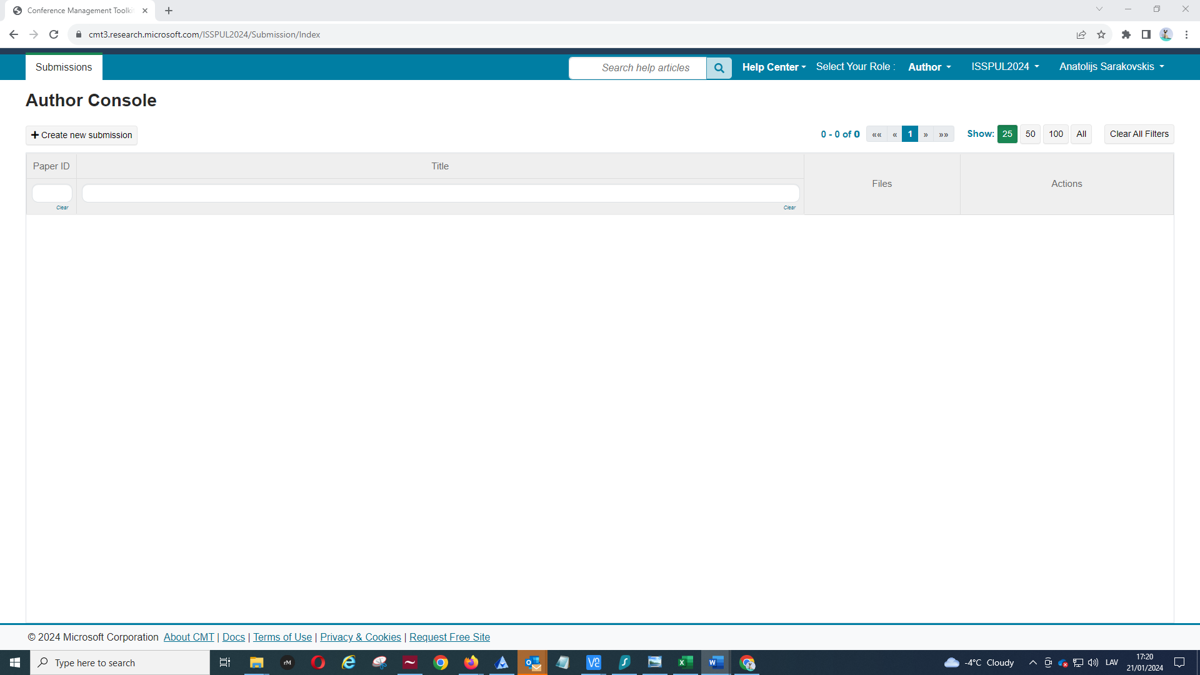

You should observe the page shown above. Press Create new submission to open the submission form.

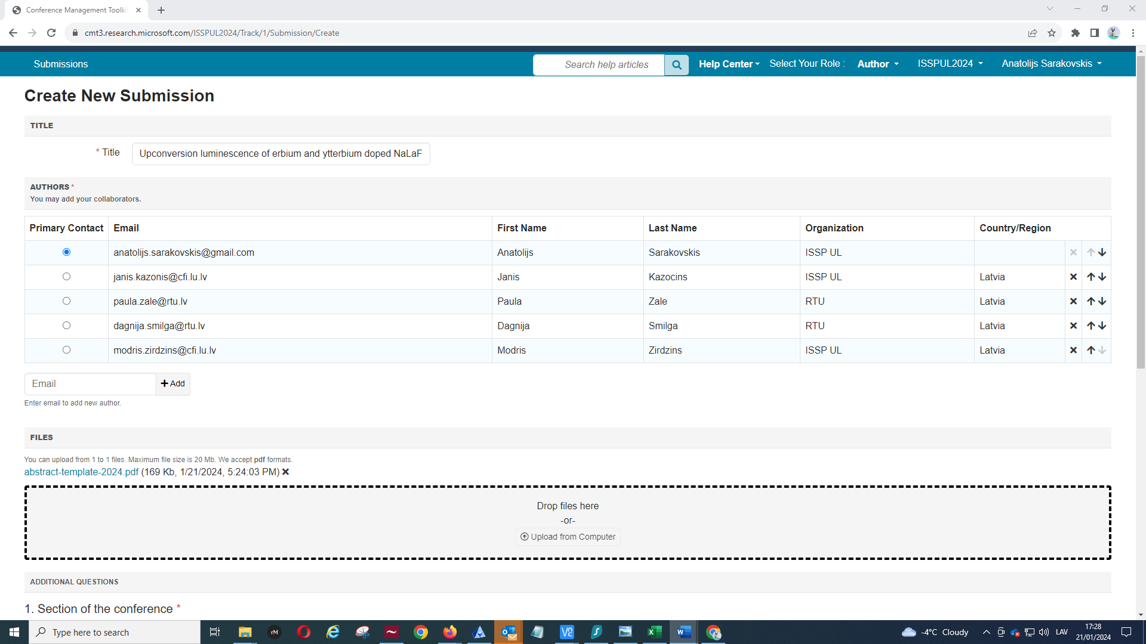
Fill the required fields:
- Title
- Authors (start with e-mail address, then additional fields with First Name, Last Name, Organization and Country will appear)
- Upload the abstract (pdf version)

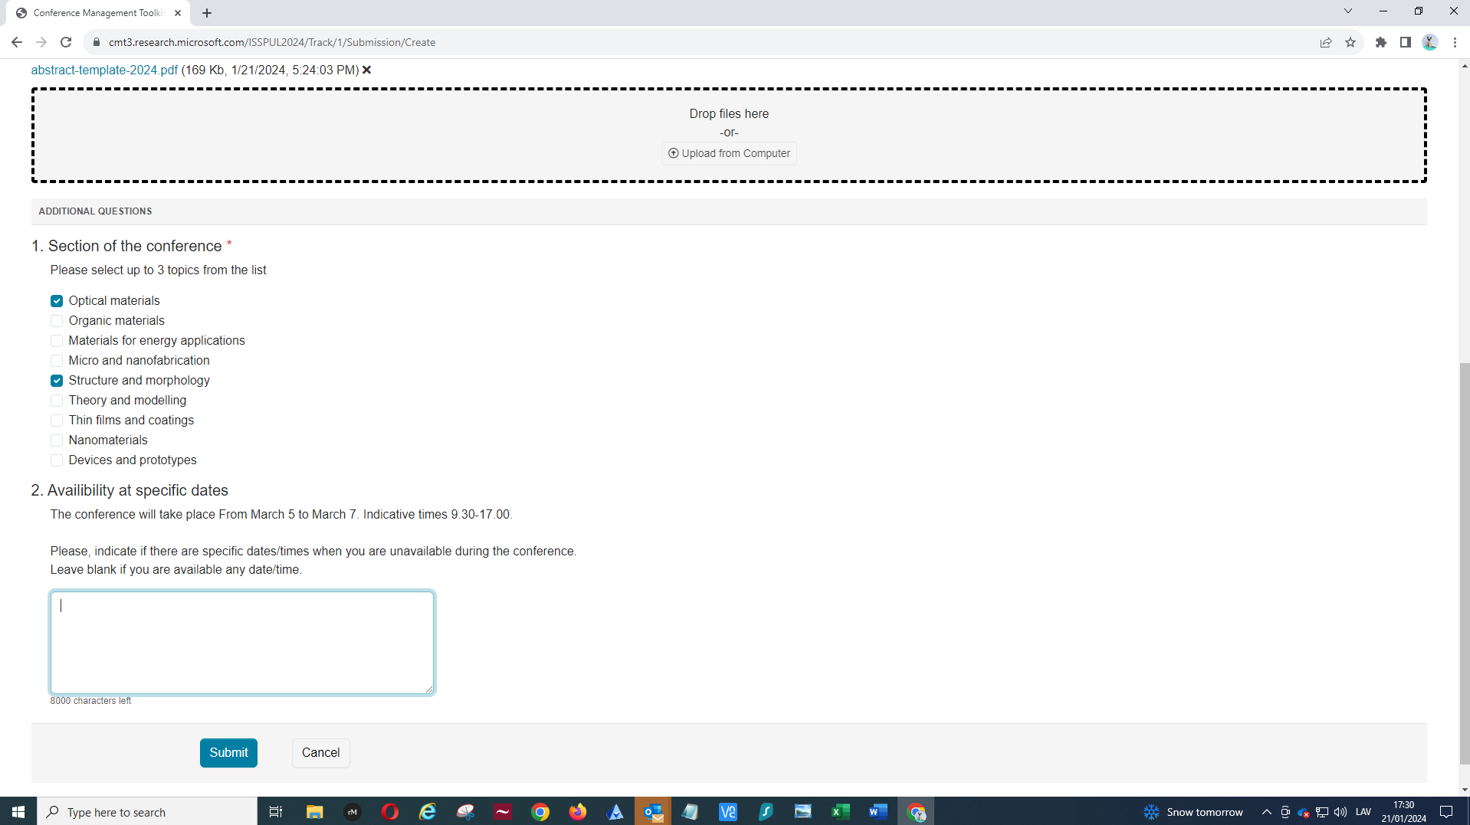
- Select up to 3 topics of the conference from the list
- If you are not available on certain dates/times, please, indicate them in the last field, otherwise – leave blank
- Press submit

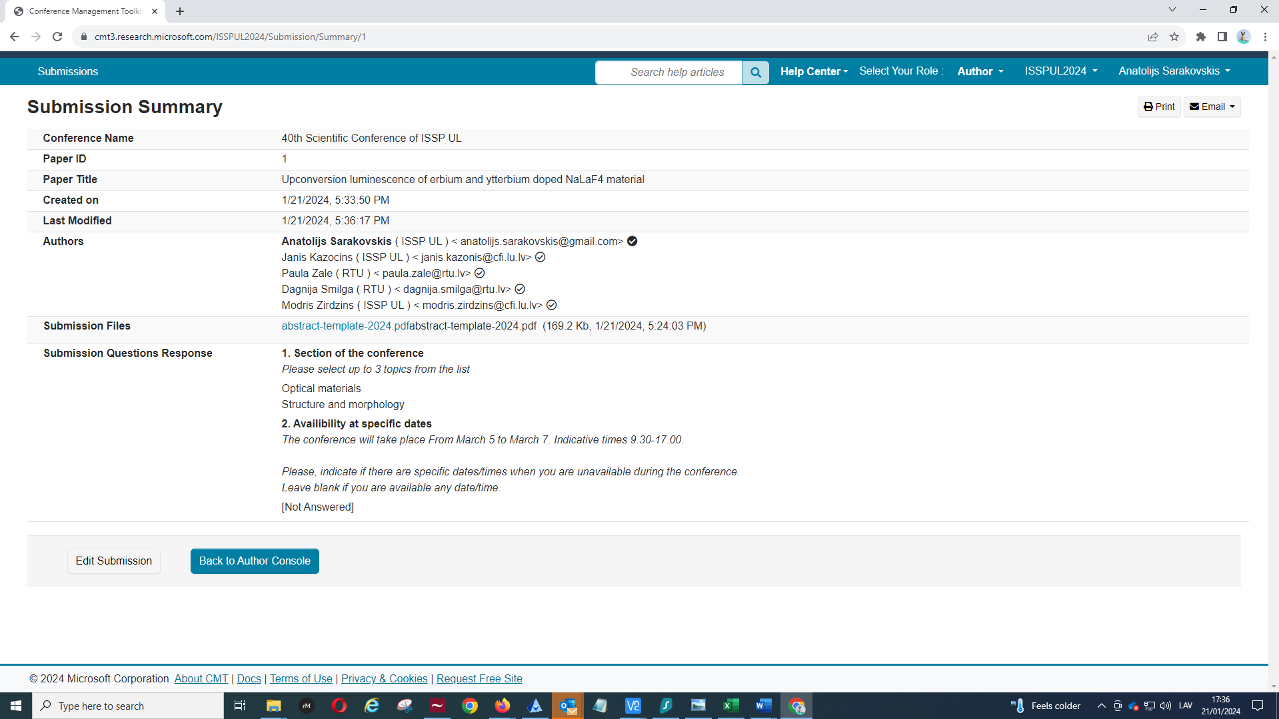
When pressed Submit, you should arrive to the following form (shown above). By pressing Email in the upper-right corner, you can send the form your coauthors and yourself.
If you want to edit your submission, you can do so by pressing Edit Submission here or by going to the author Console and selecting appropriate field. You can modify your submission (edit/delete) until the deadline of the abstract submission (February 15).
If you encounter any problems, please, send your questions to anatolijs.sarakovskis@cfi.lu.lv or contact me directly.

